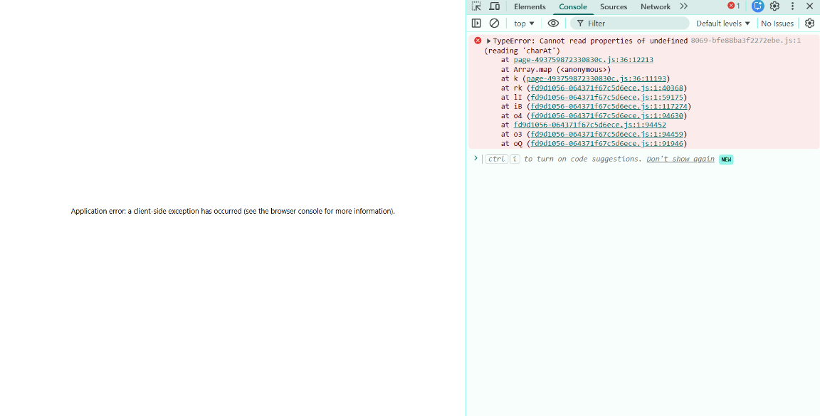
- Calendar clicked on appointments page to show appointments on a particular date – gives back this result2.2.
- Upon clicking check-in -> Generate Bill, the following error of “Route Not found” shows
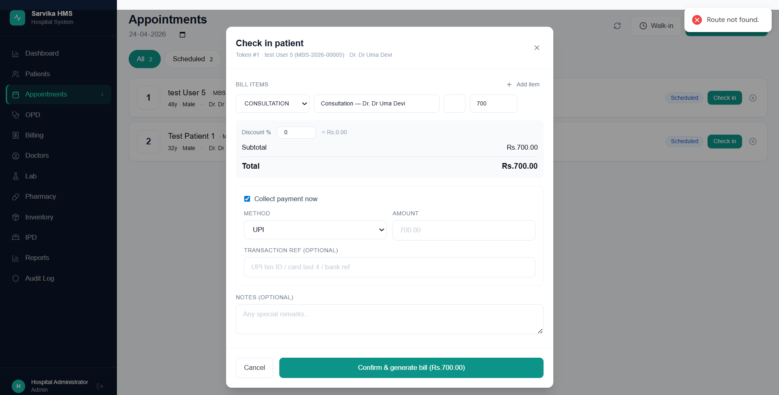
- Inactive doctors (doctors marked as inactive) – still disappears from the doctors page
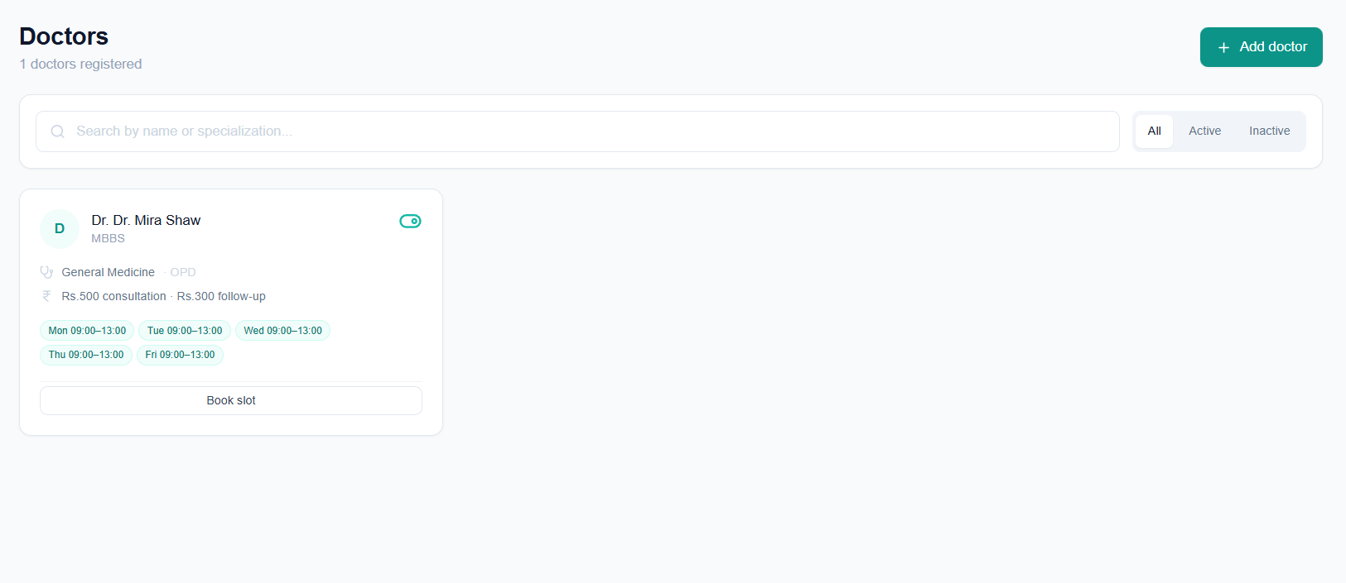

- Cannot see a doctor’s profile/manage doctor

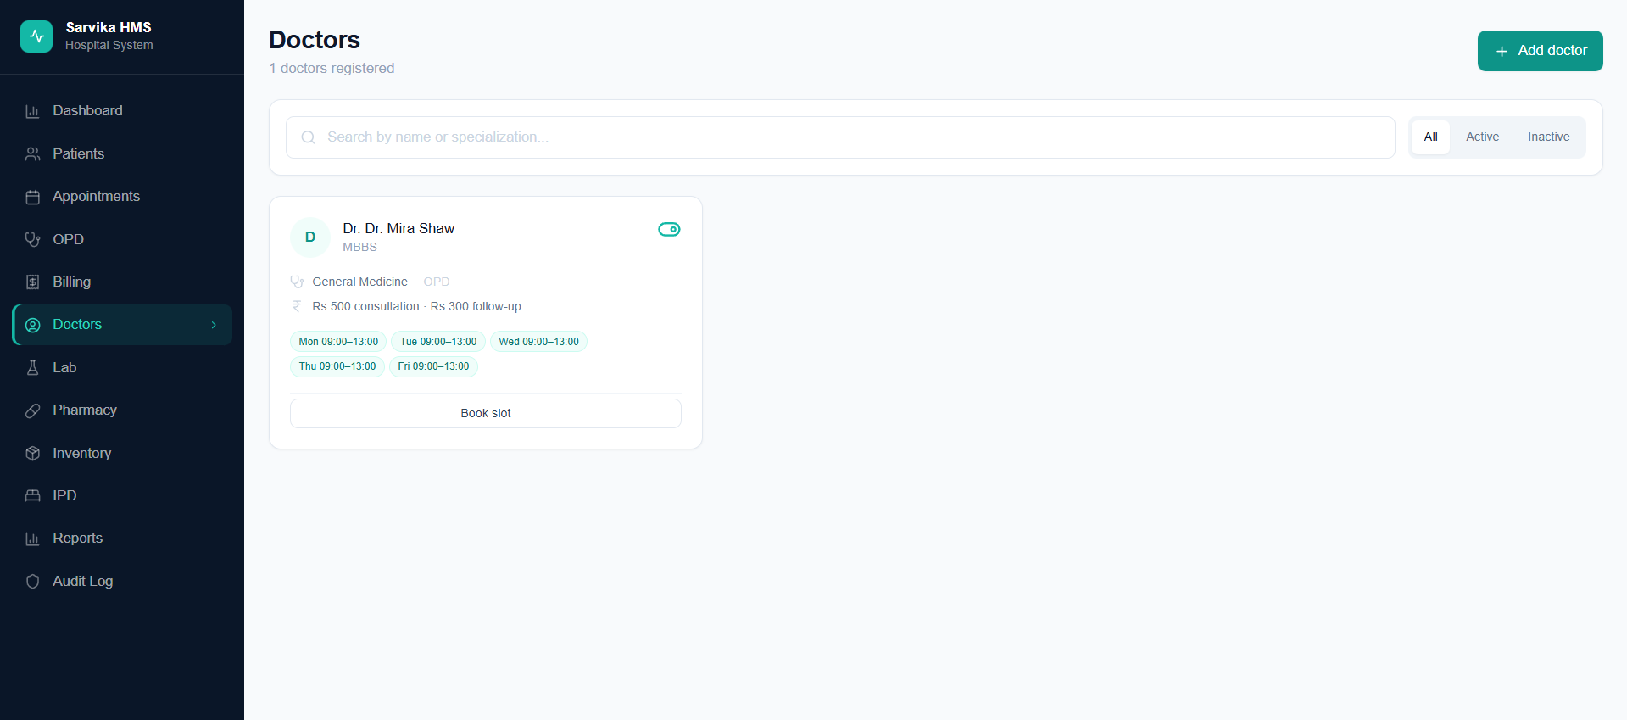
- During walk-in registration – the available doctors during the time of registration should only be shown. For the below screenshot, the doctor is available today from 9am – but I can register now only in walk-in registration. Additionally, the available slots of the doctor does not get reflected in walk-in registration.
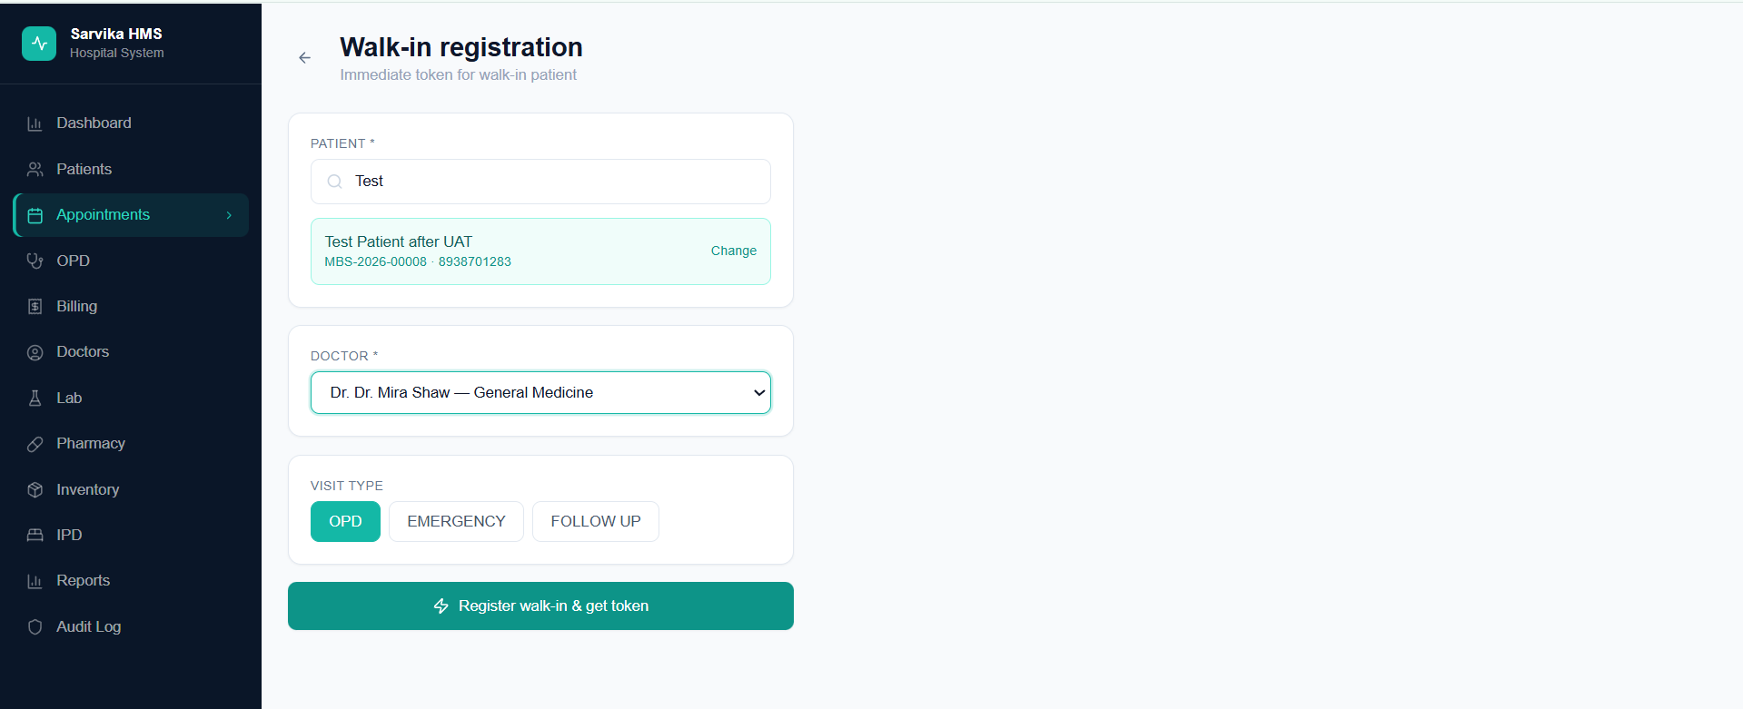
- Billing page should also have calendar view and range as well – so that user can see number of patients billed, and every other details for a particular date or a date range
- we should have an option in billing page to bill against an appointment as well
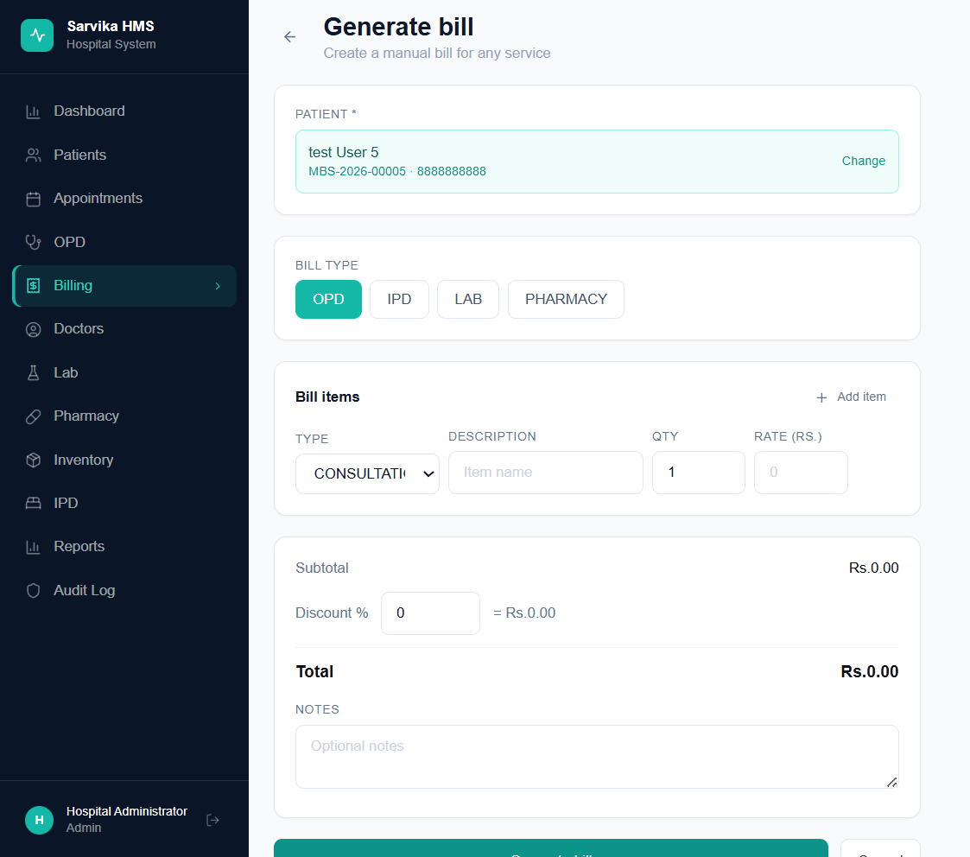

- Bill getting generated through Billing page – print invoice also prints the sidebar – which is not needed at all
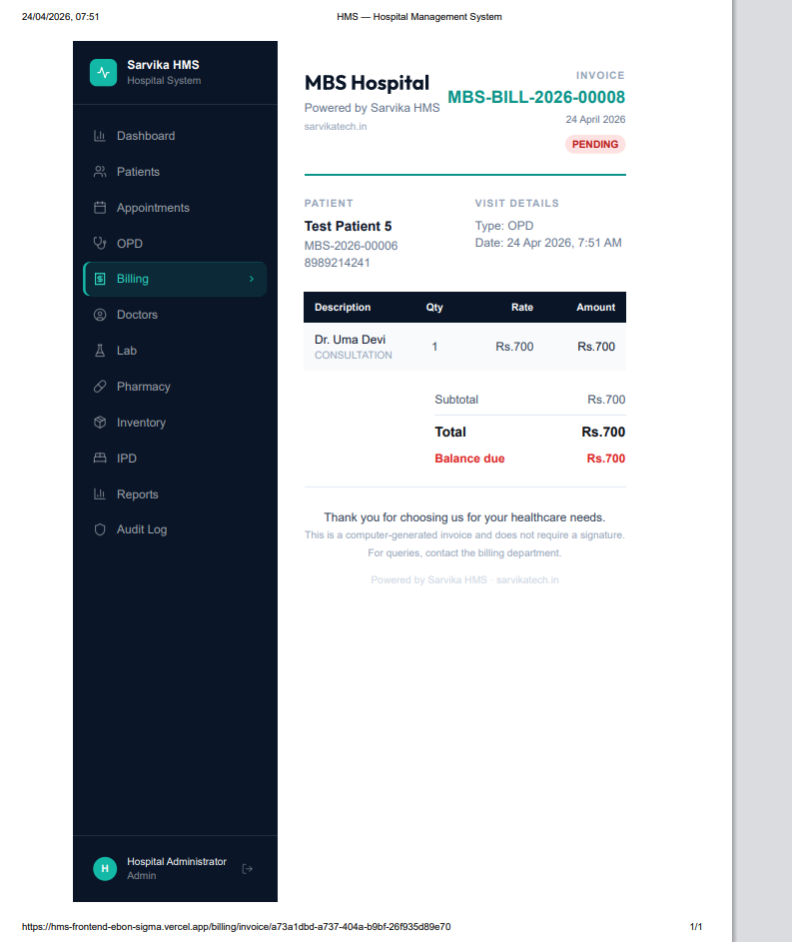

- Billing Page dashboard should have option to see pending payments from which patients and an option to receive payments as well
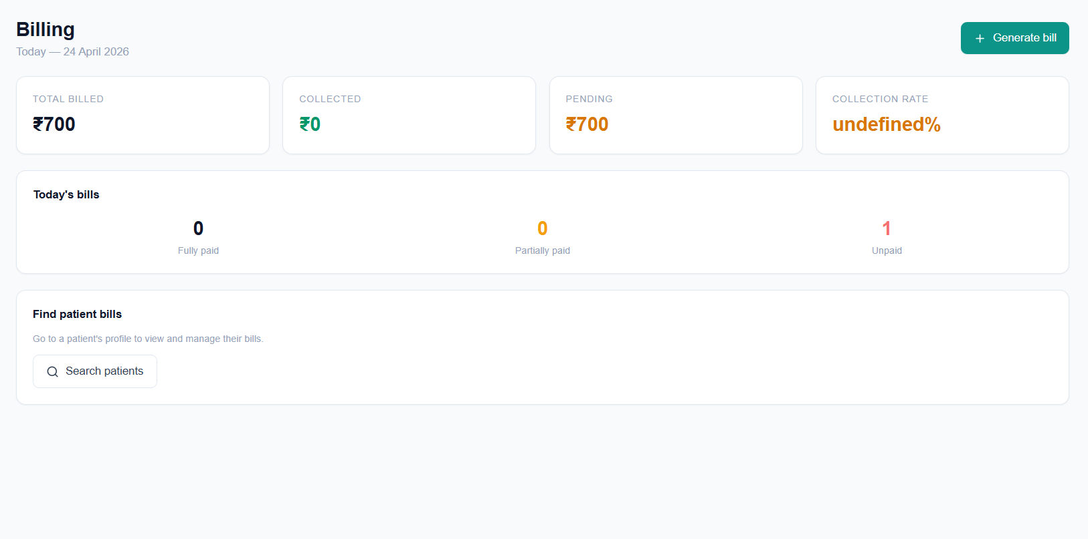
- Mobile login Interface still not corrected – the screen becomes messy upon Mobile login. Lets make it mobile compatible
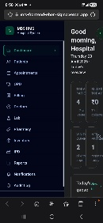
- We should put a button (like 3 dashes) for the sidebar – whenever an user clicks or hovers over the button the sidebar appears. Like every other apps.

Bug Log
Bug# | Module | Description | Steps to Reproduce | Severity | Status
B001 | Authentication & Login | User name is Shown as MBS HMS - This needs to be different for different users – personalized – the Name | Code | High | Fixed
B002 | Authentication & Login | View current user profile - The font color can be made white – it’s less readable right now |  | Medium | Fixed
B003 | Patient Management | Can we make the “State” field as drop-down like blood group while registering a patient |  | High | Fixed
B004 | Patient Management | Duplicate phone number validation - 2 Patients with same phone number got saved  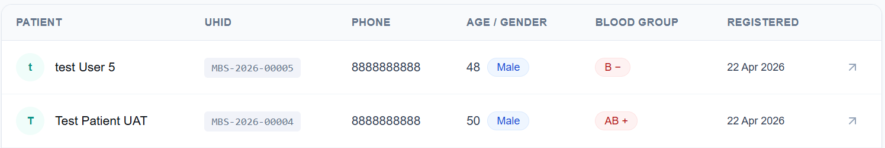 |  | Critical | Fixed
B005 | Patient Management | View patient profile — visits tab: I have tested by registering and completing an appointment with a patient – it is not getting reflected in the visits tab in patient profile. Although for Patient 2 – it is getting reflected in his visits tab but for patient 3 – it is not!  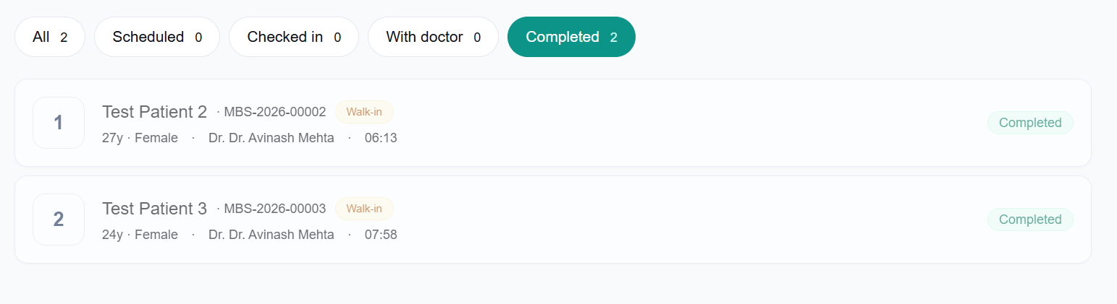  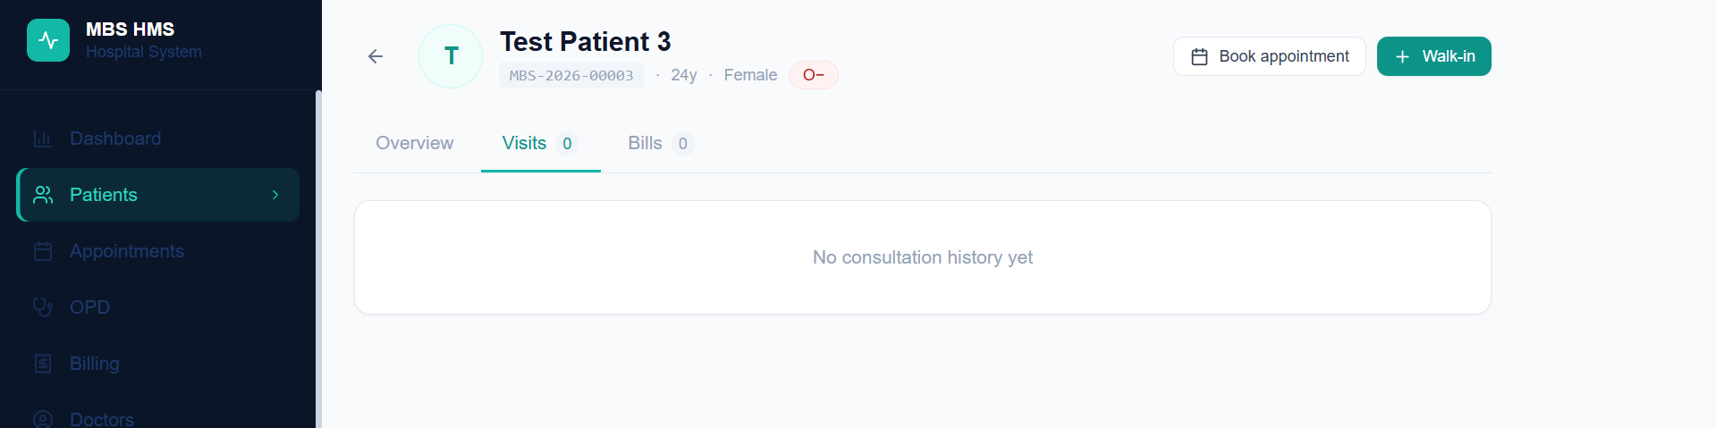 |  | Critical | Fixed
B006 | Patient Management | View patient profile — bills tab: Billing Tab not active |  | Critical | Fixed
B007 | Patient Management | Redirected to Book appointment page with patient pre-selected: Patient not pre-selected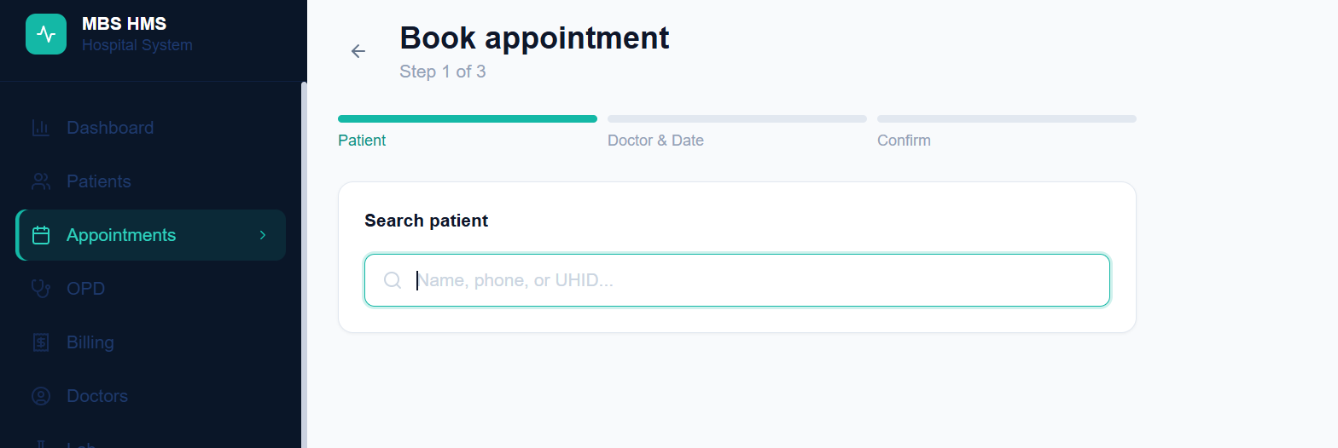 |  | Critical | Error
B008 | Doctor Management | Add doctor — Step 2 (medical profile): cannot move back from Step 2 to Step 1 while adding a new doctor. Also – if I cancel adding a doctor mid-way – the email id entered in Step 1 is retrieved somehow and I cannot re-add the doctor with that email ID  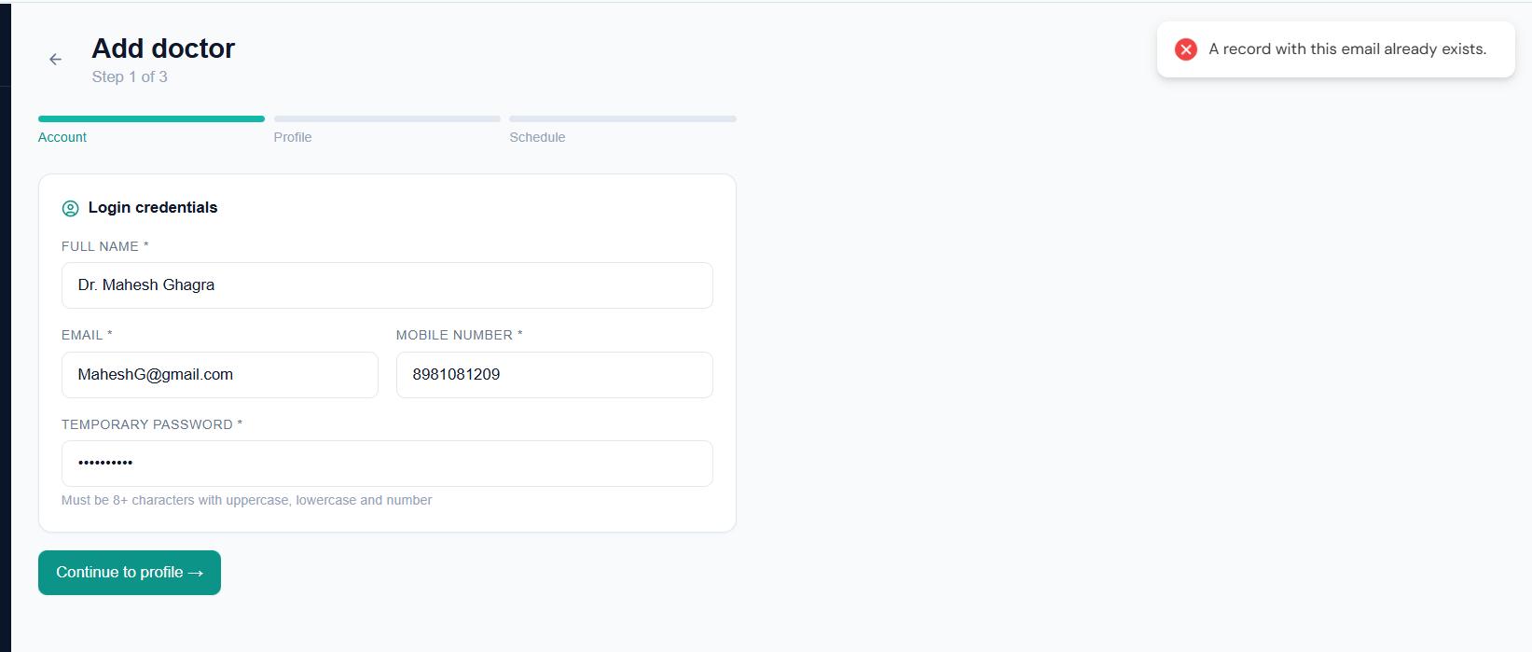 |  | Critical | Error
B009 | Doctor Management | Deactivate a doctor - We should change the color to red once a doctor is deactivated |  | Medium | Fixed
B010 | Doctor Management | “Manage Doctor” Page is not there yet |  | Critical | Error
B011 | Doctor Management | Once a doctor is deactivated and the page is refreshed – that doctor is no more shown on the doctor’s page | Can we add two tabs – active and not active doctors? | Critical | Error
B012 | Appointments & Queue - Book Scheduled Appointment | Book appointment — select doctor and slot: Once a doctor is selected in the appointments page – her available days and time slots should appear – it is not appearing at present |  | Critical
B013 | Appointments & Queue – Walk-In Registration | Register walk-in patient: Active doctor did not have today’s slot – yet walkin got registered | The existing slots for any doctor chosen should be made visible  “Doctor’s available today” should be shown while registering a walk-in patient  Once a Doctor is selected from that “Doctor’s available today” – the available slots are to be shown for booking | Critical | Error
B014 | Appointments & Queue – Queue Management | View today's queue: We should also be able to see queues for any calendar date – page not found |  | High | Error
B015 | Appointments & Queue – Queue Management | Cancel an appointment: Can we also have the cancelled data shown somewhere? |  | Medium | Fixed
B016 | OPD Consultation | Failed to Save: The consultation did not get saved – yet the patient appointment was being shown as “Completed” |  | Critical | Unknown
B017 | OPD Consultation | Completed consultation appears in patient history: Visit got updated for one patient but did not get updated for another. The one patient for whom the visit got update – we couldn’t save the OPD consultation form – error “Failed to Save” – yet the same form is being reflected in that patient’s visit |  | Critical | Fixed
B018 | OPD Consultation | Consultation completion updates queue: The consultation did not get saved – yet the patient appointment was being shown as “Completed” |  | Critical | Unknown
B019 | Billing & Payments | Only Dashboard without any numbers and all. The entire module is not functional and consultation is not getting saved. |  | Critical | Fixed
B020 |  | View patient bills: Not getting updated – consultation save failed |  | Critical | Fixed
B021 | Dashboard & Reports | Revenue stats update after consultation, Today's billed amount reflects the consultation fee: Billing not reflected in dashboard |  | Critical | Fixed
B022 | Dashboard & Reports | The “Visits Completed” in the dashboard is reflecting only 2 completed visits whereas actually there were 3 visits completed. It seems like the”Visits Completed” section on captures visits against which OPD -> “Start Consultation” Button has been clicked. For the visits which has been simply marked “completed” from the appointments page – those are not reflected in “Visits Completed” Section. We need a fix for this entire thing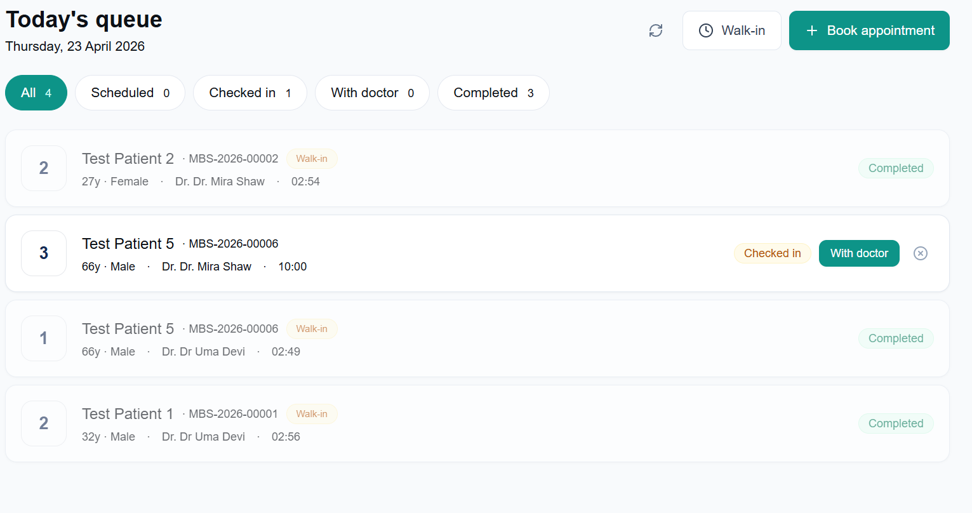 |  | Critical | Fixed
B023 | Dashboard & Reports | Dashboard shows collection rate: Not showing |  | Critical | Error
B024 | Dashboard & Reports | Quick actions work, On Dashboard, click each quick action button: Register patient, Book appointment, Walk-in token, Generate bill: Generate Bill Page is not found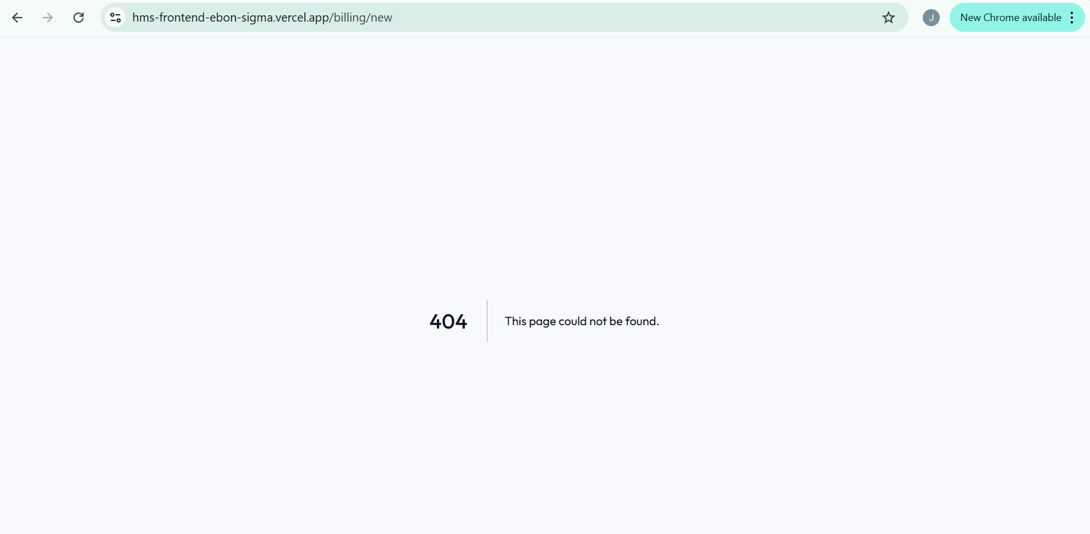 |  | Critical | Fixed
B025 | Navigation & layout | Logo and brand visible: Hospital System” subtitle font color to be changed to make it better readable |  | Medium | Fixed
B026 | Navigation & layout | Open app on mobile browser – FAIL   |  | Critical | Error
B027 | Security & Compliance | Open https://api.sarvikatech.in/health in browser: Success - False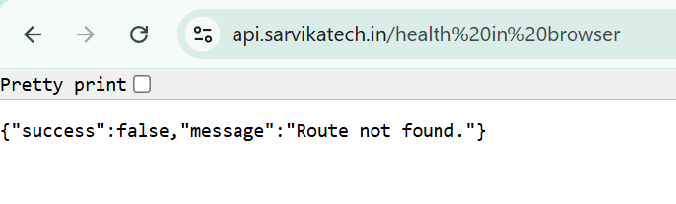 |  | High | Fixed
B028 | Security & Compliance | Log in and out. (Audit logs viewable via API for now.): Audit Logs are not built yet |  | Medium

